WINCANTON SWIMMING CLUB
MASTERS MEMBERSHIP FORM
Welcome to Wincanton Swimming Club. Please complete and return to adele@theparhams.co.uk
Swimmers Name
Address

Email address
Telephone
Gender
 | Home: |  |  |  |  | Mob:
 | Male |  | Female |  | Date of Birth
Do you have an ASA registration number? | Y/N |  | ASA number: |  |  |  |  | First Claim Club name
Medical Conditions
Emergency Contact Name
Emergency Contact  Telephone number |  | mobile |  |  |  |  | home

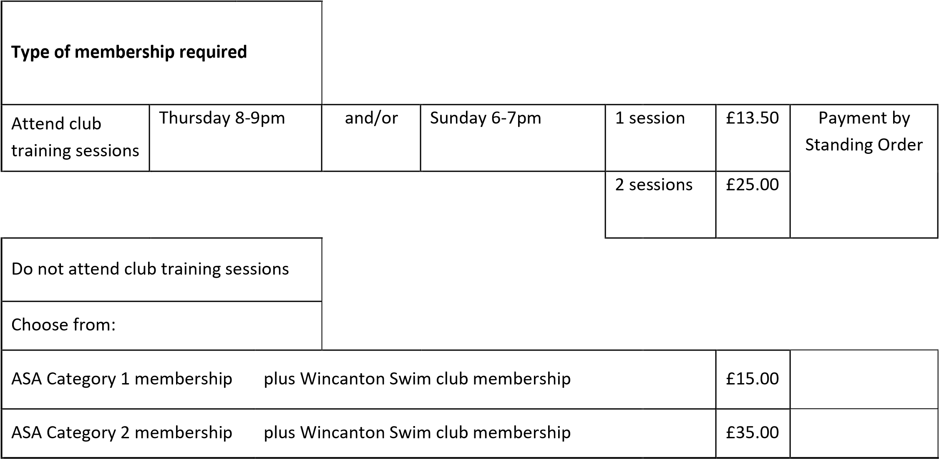

Cost for 2nd Claim to Wincanton Swim Club membership is £10.00 only
Payment can be made by cheque or BACS payment to Lloyds Bank s/c 30-93-45 a/c nbr 00999629

The club may wish to take photographs of individual or groups of swimmers during their membership of the club. All photographs will be taken and published in line with the ASA Photography Policy. Please note you can withdraw your consent in writing to the club Welfare Officer at any time should you wish to do so.
Photos to be used on the Club secure website YES/NO
Photos to be included in newspaper articles YES/NO

Data Protection Act – Privacy Policy
- In compliance with the General Data Protection Regulation 25 May 2018, we will ensure that all information held by the club is accurate, kept up to date and secure and that it is used only in connection with the purpose and activities of the Club. We will hold the data for 3 years after your last contact or from when you leave the club and then any information will be destroyed.
The information will be disclosed only to those members of the Club / Swim England for whom it is appropriate and necessary. Swimming England has registered with Data Protection on behalf of member Clubs, counties and regions, enabling them to hold personal data of members etc.
Records are kept on computer / paper based platforms. Keeping information in this way enables us to run the club more efficiently.
- By signing below you are consenting to Wincanton Swim Club holding your personal data for the purposes of this application as set out above and to give us permission to contact you.
- You can request information is deleted before the 3 years by contacting adele@theparhams.co.uk.

Application for Membership
- I have no objection to information regarding me being kept on computer.
- I agree to all the conditions of membership as outlined on this form.
- I acknowledge that by sending this form I confirm that my answers to the questions are a true and accurate reflection of my situation.
- I acknowledge receipt of the rules of Wincanton Swimming Club and confirm my understanding and acceptance that such rules (as amended from time to time) shall govern my membership of the Club. I further acknowledge and accept the responsibilities of membership upon members as set out in these rules.
Full Name of Member _________________________

Signature ________________________ Date __________________________

